Jenkins day 4 task

Step 1: Installing Jenkins in the EC2 instance

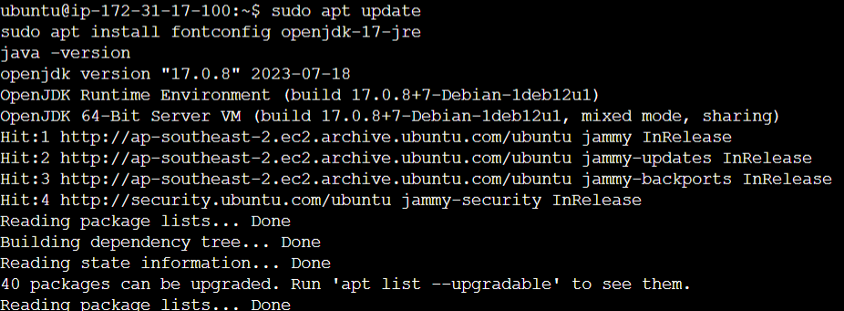

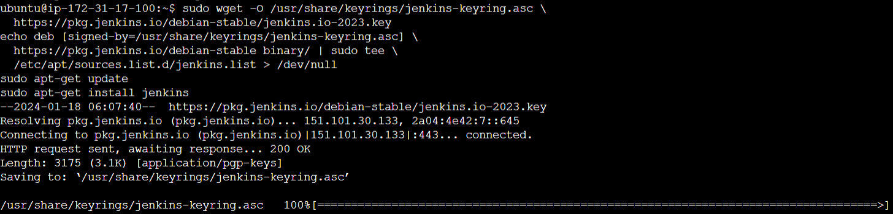

Step 2: updating the security groups in the instance  
  


Step 3: setting up Jenkins



Step 4: creating a project in Jenkins

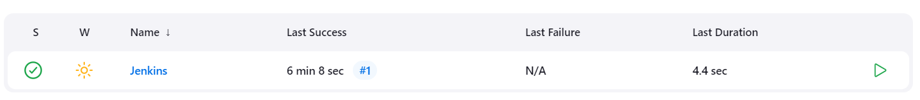

Step 5: Adding webhooks in Git hub

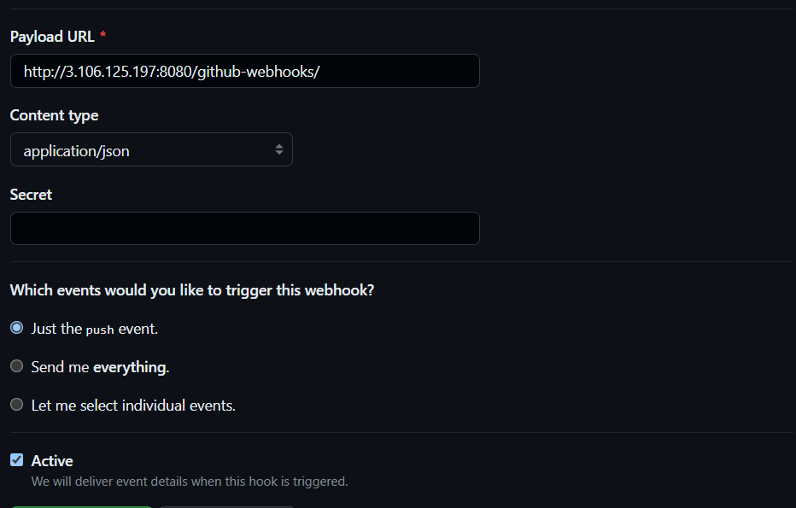

Step 6: Configure GIThub in Jenkins

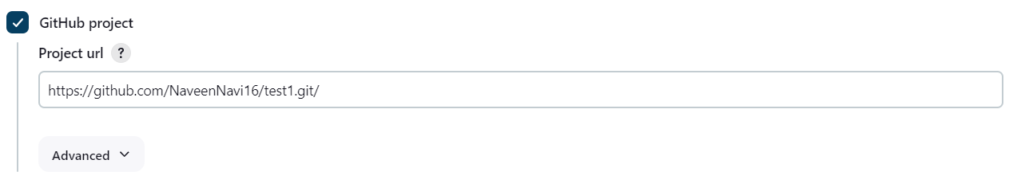

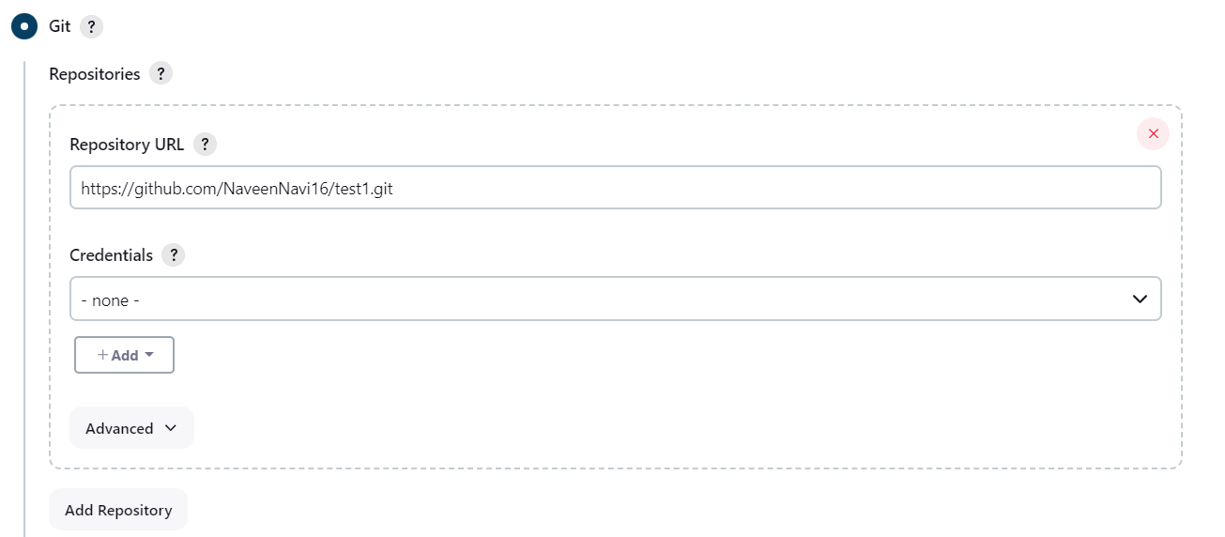

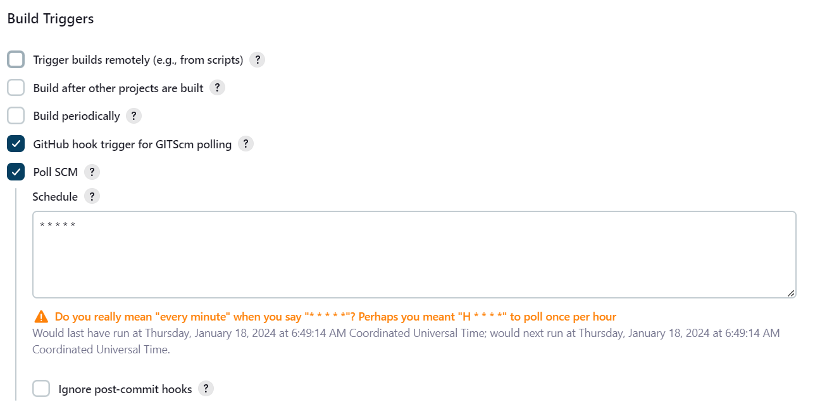

Step 7: Triggering mail

